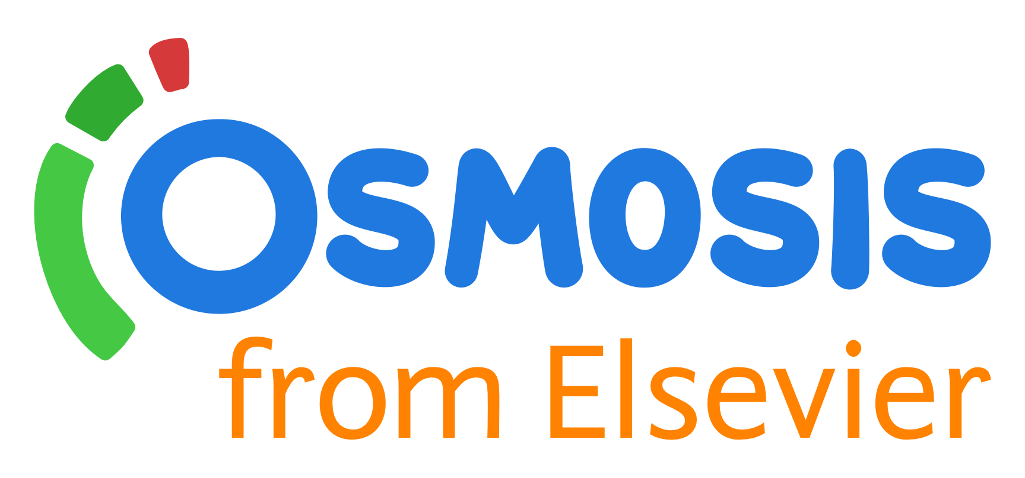
Cohort Invite - Osmosis

IMPORTANT !!! - only below domains for registration
@student.uj.edu.pl @doctoral.uj.edu.pl @uj.edu.pl

